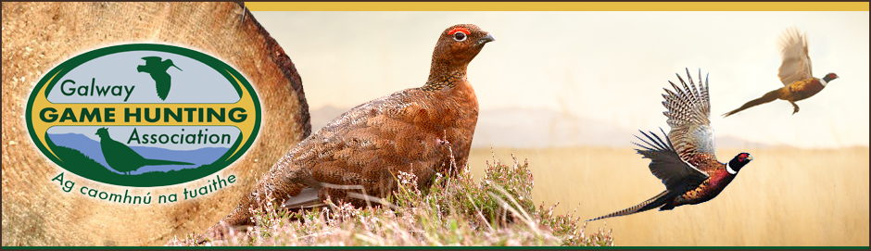
Club Activities Promotion Grant
The GGHA makes available financial support for the purpose of promoting club activities within local schools and organisations (scouts, tidy towns etc.) to affiliated clubs who participate in the AND submit Bag Return Forms.
A budget of €2000 annually is allocated to the programme and this funding is provided to subsidise the cost to clubs (at a rate of 50%) of supplying bird tables, bird boxes, bat boxes, owl boxes and wild bird feed etc.
The maximum grant aid available per club is €200 and where the overall annual programme budget is exceeded, the support will be paid out on a pro rata basis across all clubs who qualify for grant aid.
Completed signed and dated application forms must be received by the GGHA Game Development Officer on or before the stated deadline, and all applications must be accompanied by original printed receipts.
Photographs of the presentation of equipment etc. should be taken where possible for promotional purposes, with the necessary permissions being sought from those involved.

Club Activities Promotion Grant
Club Name:

Officer  Contact Details | Name:
 | E-mail:
 | Phone:

Type (e.g. bird tables, bird boxes, bat boxes, owl boxes, wild bird feed etc. | Sub-total
 | €
 | €
 | €
 | €
 | €
 | €
 | €
Total | €

Signed__________________________________ Date_______________
Completed form AND original receipts to be received
on or before 1st July on a given year by:
The Game Development Officer with the G.G.H.A

