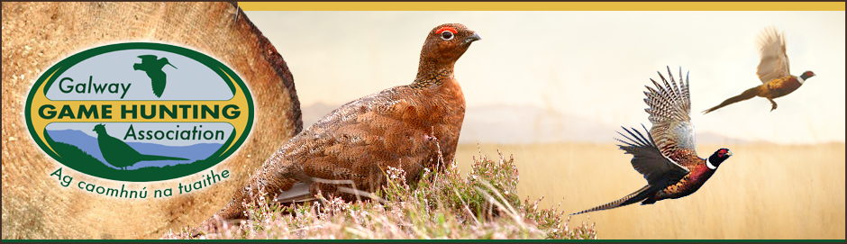
GGHA Club of the Year Award

The GGHA operates a Club of the Year Award. The Award is intended to recognize quality management practices which contribute to the development of Gun Clubs and the game stocks on Club lands.
The most successful Clubs from each RGC will be entitled to participate in the NARGC Club the Year Award. The closing date for entries for club of the year is 10th MAY on any given year as the national closing date is the 16th May on any given year.
Assessment Criteria
Clubs will be allocated points under the following headings:
• Club Structure - 80 points
• Habitat Development - 150 points
• Predator Control - 110 points
• Game Releasing - 100 points
• Public Relations - 80 points
• Participation in Surveys - 80 points

Total 600 points
Eligibility and Focus
Clubs are not expected to be involved in all of the categories listed in the assessment criteria. The GGHA will be mindful that, in many cases, Clubs can only use the resources that are available to them, which depend on local conditions and land use characteristics.
In general, the Award aims to encourage innovation and new concepts of management at Gun Club level in connection with local agriculture and environmental conditions. In particular, Clubs will be rewarded for their habitat management practices, including the creation of new habitats for game birds and the recovery and management of other natural/local habitats in collaboration with local landowners.

Application Procedure
Gun Clubs interested in participating in the GGHA Club of the Year Award competitions should put together a short application outlining their work under the six headings listed in this leaflet:
• Club Structure
• Habitat Development
• Predator Control
• Game Releasing
• Public Relations
• Participation in Surveys

We recommend that Clubs also use the sub-headings, within each category, as a guide.
Clubs that participate in this Award will be examined (based on their application form and site visit) by relevant officers within the GGHA and two external individuals from another RGC to ensure consistency in scoring.
Prizes
The GGHA Club of the Year Award Winner will receive a perpetual trophy and the following sum of money: First Place: €400 Second Place: €100
Application Deadline will be communicated to secretaries and be listed on GGHA.ie
Assessment Criteria
Gun Clubs should use the headings in this form as part of their application to the GGHA Club of the Year Competition. If you have any questions, please contact the GGHA Game Development Officer.
Clubs will be allocated 600 points under the following headings:
Club Structure
• Club Constitution
• Club Committees
• Club Events, Projects and Activities
• Attendance and Frequency of Meetings
• Social Events
Habitat Development
- Extent of Land under Active Habitat Management
- Game Crop Provision
- Duck Pond Management
- Provision of Supplementary Feeding
- Woodland/Field Margin/Hedgerow Management
- Other (e.g. heather, wetland, specialist partridge management)
- Establishment of Actively Managed Sanctuary Sites
Predator Control
• Recent Predator Records
• Methods used to control the following species:
• Corvid
• Fox
• Mink
• Other (grey squirrel, pigeon, rat)

• Predator Control Equipment
Releasing Game
• Species of game birds released
• Releasing Methods
• Incubation/Propagation of game
• Quantity, Size and Location of Release Pens
Public Relations
• Cooperation with Landowners
• Club Fund-raising and Sponsorship
• Charity Work
• Other Policies (e.g. Youth Policy, Safety Policy, etc.)
Participation in Surveys
• Members’ participation in Game Bag Returns
• Members’ participation in Snipe/Woodcock surveys
• Members’ participation in RGC and NARGC events
All application must be sent to the Game development officer on or before the closing date 10th MAY on any given year.

