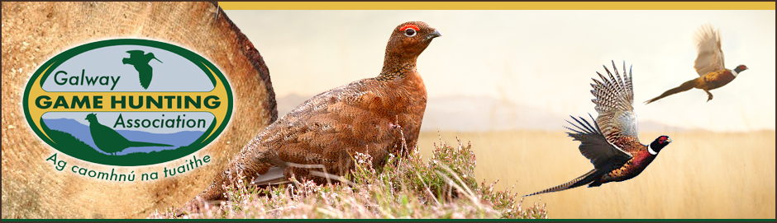

Game Bird and Wildfowl Grant Programme
The GGHA makes available financial support towards the purchase of pheasant poults / Adults, mallard ducklings and partridge chicks to affiliated clubs who participate in the GGHA Vermin Control Competition AND submit Bag Return Forms.
A budget of €4000 annually is allocated to the programme all this subsidy will be divided between clubs for birds purchased from Irish suppliers. With a max of €500 per club to be payed for Ducklings, Pheasant (Poults) (Adults), Partridge (chicks)
The purchase of adult pheasants from Irish suppliers is also subsidised and is been increased to €200 per club under this part of the scheme.
Where the overall annual programme budget is exceeded, the support will be paid out on a pro rata basis across all clubs who qualify for grant aid.
Completed signed and dated application forms must be received by the GGHA Game Development Officer on or before the stated deadline, and all applications must be accompanied by ORIGINAL printed receipts or invoices.
All clubs are advised to satisfy themselves as to the health status of the game birds and wildfowl they purchase, and only use reputable suppliers.

Game Bird and Wildfowl Grant Application
Club Name:

Officer  Contact Details | Name:
 | E-mail:
 | Phone:

 | Quantity | Date Delivered | Sub-Total
Pheasant (Poults) |  |  | €
Pheasant (Adults) |  |  | €
Mallard (Ducklings) |  |  | €
Partridge (Chicks) |  |  | €
Total |  |  | €

Signature_________________________________ Date_______________
Completed form AND receipts to be received on or before 24th April on given year by:
The Game Development Officer with the G.G.H.A

