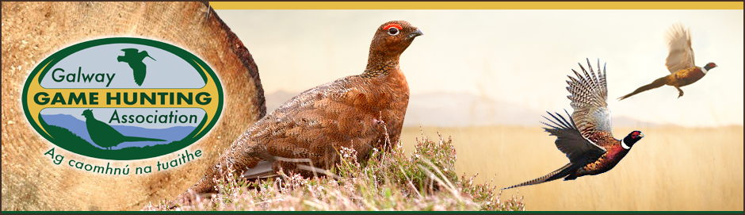
Duck Nesting tube materials purchase Form
The GGHA are Making available financial support towards the purchase of material to produce duck tubes for mallard breading and hopefully increase the number of ducklings, Keeping the duck nests safe from predators during the hatching period.
A Grant of €500 per club when they purchase materials to make Duck tubes and situate them in ponds/rivers/wide drains where wild mallard are known to hatch.
Completed signed and dated application form must be received by the GGHA Game Development Officer on or before the stated deadline; ( 1ST September on the given year)
All applications must be accompanied by ORIGINAL printed receipts or invoices. Any late Application Forms will not be accepted.
Please attach photographic evidence of the duck tube in its final position.
How to Make
Materials
•Medium tensile garden wire mesh – 1m x 2.2m x 2.5cm mesh
•Cable ties/wire strips or hog rings
•Hay
•Scaffold tube/post – size dependent on the depth of water and how soft the bottom is – finished height to be 2ft above water
•Either a metal frame or a wooden plank fixed to metal pole as per the online video (see link below).

Construction
1.Cut your length of wire to 7ft (2.2m)
2.Roll the wire on a flat surface to make a 30cm diameter cylinder, securing the join using cable ties or, better still, wire
3.Over the remaining flat wire spread an even covering of hay approx. 2in thick, ensuring there are no gaps
4.Continue rolling the wire, creating an outer cylinder enclosing a layer of hay
5.Fix the end of the wire to secure the outer layer
6.Pack more hay into the outer cylinder to fill in any gaps
7.Once you are happy with it, fix the tube to either a base or cradle
8.Put some loose hay into the tube to give a base layer of bedding.
Her is a link to making a Duck Nesting Tube or Duck Hen House https://www.youtube.com/watch?v=CuS9fCf1Eug

Duck Nesting tube materials purchase Form
Club Name:

Officer  Contact Details | Name:
 | E-mail:
 | Phone:

Material type | Quantity | Date bought | Sub-Total
 |  |  | €
 |  |  | €
 |  |  | €
 |  |  | €
Total |  |  | €

Signature_________________________________ Date_______________
Completed form AND receipts to be received on or before
(1st September on the given year) by:
The Game Development Officer with the G.G.H.A
Martin Fallon, 2 Clareview, Claretuam,
Co Galway

