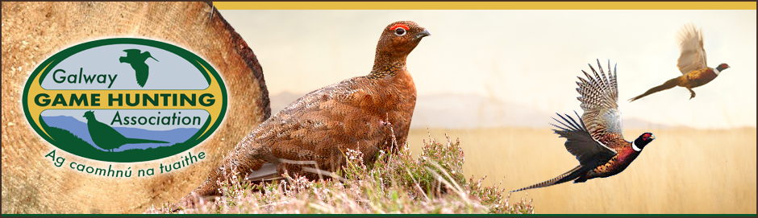
Club Affiliation Form
This form MUST be completed in full
Full Club Name

Club e-mail address

Chairman Name Address

Phone

e-mail

Secretary Name Address

Phone

e-mail

Treasurer Name Address

Phone

e-mail

Clay Pidgeon officer Contact Name Address
Phone
e-mail

Vermin officer Contact Name Address
Phone
e-mail

Game development officer Contact Name Address
Phone
e-mail

Safety officer Contact Name Address
Phone
e-mail
In accordance with the terms of the NARGC constitution, NARGC Compensation fund and GGHA constitution, all GGHA affiliated clubs must consist of members within the NARGC Compensation fund and as such shall be associated members of the NARGC. No club can consist of members who are not insured by the NARGC Compensation fund. Failure to ensure all club members are within the NARGC compensation fund will nullify club officer’s compensation fund coverage.
NARGC Constitution - Article III (c)
All members of gun clubs which are affiliated to Affiliated Bodies must be members of the Game Compensation Fund and shall be Associated Members of the NARGC (amended at EGM July 2nd 2005)

NARGC Compensation Fund Contract
to protect all officers and trustees during their terms of office in all organs of the association while in the course of discharging their official duties of office in the terms of part 5 save in respect of the exception protection referred to in part 8 (4) (c) hereof. Where this protection applies to officers of gun clubs, game protection associations or local clubs otherwise termed, such protection will only be given where EACH AND EVERY member of the club/association, associate member or by whatever name termed, is a member of the compensation fund

GGHA Constitution: 4. Affiliation
a. Gun Clubs, all of whose members whether Honorary, full or by whatever described, are members of the G.H.C.F. shall be eligible.

We hereby declare that all members of _________________________________ are members of the NARGC Compensation Fund. (Insert Club Name)

In accordance with the Data Protection Laws and in particular the GDPR, we hereby consent to the Galway Game Hunting Association (GGHA), to release the information set out herein to the Authorities of the State and other Sporting bodies for the purposes of my sport, should same be required and we acknowledge that by our signatures that we understand that although we are not required to release our information, we are giving our consent to do so. Additionally, we understand that we may revoke this authorization in writing at any time, except for that information which has already been released with consent and prior to my revocation, by my writing to the Hon. Secretary of the GGHA. We further confirm that the within authorization constitutes consent to the GGHA for use of our data for Administration purposes in accordance with the Constitution of the Association.
Club Chairman_____________________________ Date_______________
Signature
Club Secretary_____________________________ Date_______________
Signature
Club Treasurer_____________________________ Date_______________
Signature
The Club affiliation Fee (€50) AND application form must be returned on or before 31st July, on each given year: Tom Moran, Melliah, Cloon, Claregalway, Co. Galway. H91EPP5

NO club membership will be processed without the affiliation being paid (all cheques payable to Galway Game Hunting Association)

