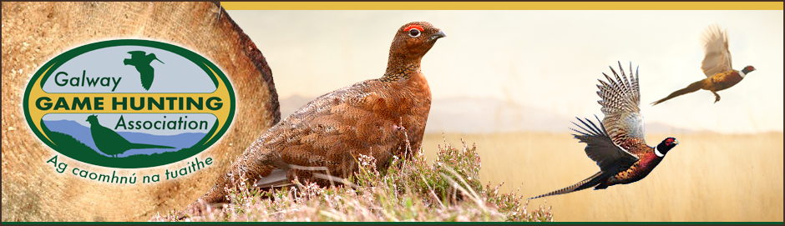
Game Crop Development Programme
The GGHA makes available financial support towards the cost of sowing suitable game crops to affiliated clubs who participate in the GGHA Predator Control Competition AND submit Bag Return Forms.
A budget of €4000 annually is allocated to the programme and this funding is provided to subsidise the cost of fencing material, fertiliser and where appropriate, machinery hire to a maximum of 50% of the overall cost. All claims for ancillary costs (fencing material, fertiliser and machinery hire) MUST be accompanied by appropriate original official receipts.
There is also a provision for a once off development payment, approval for which must be sought in advance from the GGHA Executive.
Please note that the maximum financial assistance payable to any one club is €500 per annum and where the overall annual programme budget is exceeded, the support will be paid out on a pro rata basis across all clubs who qualify for grant aid.
To ensure that suitable game crop is sown, as part of the programme the GGHA will supply the necessary seed directly to clubs. Completed signed and dated application forms must be received by the GGHA Game Development Officer on or before the stated deadlines.
The purchase price of this seed has been subsidised at a rate of 50% by the GGHA from the overall programme budget, and the available seed mixtures are:

- Wild Bird Cover Special (a mixture of Triticale, Linseed, Mustard and Phacellia available in 22kg/0.6 acre packs @ €17.00 each)
- Standard Wild Bird Mix (a mixture of Triticale and Linseed available in 18kg/0.5acre packs @ €15.00 each)
- Wild Bird Mix with Phacellia and Quinoa (available in 18.5kg/0.5acre packs @ €17 each)

- Wild Bird Mix with Mustard and Gold of Pleasure (available in 19kg/0.5acre packs @ €17 each)
- Grey Partridge Mix a highly recommended mixture Triticale 8kg , Kale .6kg, Lucerne .8kg , Chicory .4 kg , Radish 2kg bags available in 10kg for 0.5 acres packs @ €18 each
- Game crop cover 2 year mix Sunflowers 4kg,White millet 2.63kg,Buckwheat 1.87kg,Quinoa 1.5kg,Coleor Kale 1.74kg (low type),Phacelia 0.38kg,White mustard 0.25kg,Chicory 0.13kg. 12.5kg bag (1 acre pack) €32 per bag.
Game Crop Order Form 2022
Club Name:

Officer  Contact Details | Name:
 | E-mail:
 | Phone:
Type |  | Quantity | Sub-total
Wild Bird Cover Special  Triticale, Linseed, Mustard and Phacellia |  | 0.6 acre @ €17 each | €
Standard Wild Bird Mix  a mixture of Triticale and Linseed |  | 0.5 acre @ €15 each | €
Wild Bird Mix with Phacellia and Quinoa |  | 0.5 acre @ €17 each | €
Wild Bird Mix with Mustard and Gold of Pleasure |  | 0.5 acre @ €17 each | €
Grey Partridge Mix |  | 10kg for 0.5 acres packs @ €18 each | €
Game crop cover 2 year mix  Sunflowers, White milled, Buckwheat, Quinoa, Coleor Kale (low type),Phacelia, White mustard, Chicory |  | 12.5kg bag (1 acre pack)  €32 per bag. | €
Total |  |  | €

#Completed form AND payment to be received on or before 08th April on each given year by: The Game Development Officer with the G.G.H.A
Signed_____________________________________ Date_______________

Game Crop Development Programme Ancillary Costs
Club Name:

Officer  Contact Details | Name:
 | E-mail:
 | Phone:

Fencing Material | €
Fertiliser  (maximum €40 per acre) | €
Machinery Hire Cost | €
Once Off Development  (must be pre-approved by the GGHA Executive) | €
Total | €

Signed___________________________________ Date_______________

Completed form AND original receipts to be received
on or before 22nd June in each given Year.
by: The Game Development Officer with the G.G.H.A

