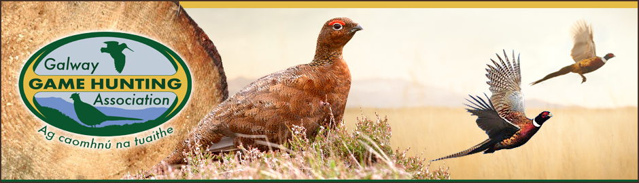
NARGC/GGHA Mink Bounty Scheme
Club Name:

Officer  Contact Details | Name:
 | E-mail:
 | Phone:

Number of Tails | Date of Capture | Method of Capture | Sex:  M or F | Overall Length (cm) | Location of Capture (Townland, River, etc.) | Method of Dispatch = shot

Signed__________________________________ Date_______________
This form must be given to the GGHA Vermin Counter with mink tails. All parts of the form must be completed, and the information should match the number of tails submitted.
All tails are to be retained by GGHA Vermin Counters and complete with this form, given to: Vermin control officer.

