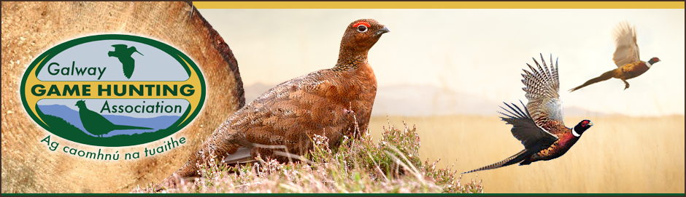
GGHA Vermin Control Grant Programme
The GGHA makes available financial support for the purchase of vermin control equipment, trail cameras and dog location collars to affiliated clubs who participate in the AND submit Bag Return Forms.
This support is provided at a rate of 50% of the receipted purchase price of equipment items, and a budget of €4000 annually is allocated to the programme.
Where the overall annual programme budget is exceeded, the support will be paid out on a pro rata basis across all clubs who qualify for grant aid.
Completed signed and dated application forms must be received by the GGHA Vermin Control Officer on or before the stated deadline, and all applications must be accompanied by original printed receipts.
While suitable habitat is a key requirement for wildlife development, vermin control is the cornerstone which ensures that any game subsequently released does not simply become food for predators. These measures also have the bonus of affording wild game the maximum opportunity to breed successfully, which is the most economical and environmentally friendly means of game propagation.
The GGHA reminds all clubs and members of the derogations in force regarding the control of vermin and in particular the use of Larson traps.
Vermin count Dates for 2023 are
May 5th
Aug 11th
Dec 1st
All counts take place at 8.00 pm

GGHA Vermin Control Grant Application
Club Name:

Officer  Contact Details | Name:
 | E-mail:
 | Phone:

Type | Sub-total
Vermin Control Equipment | €
Trail Camera, | €
Dog Location Collar | €
Total | €

Signed___________________________________ Date_______________

Completed form AND original receipts to be received
on or before 1st December on the given year.
Only Vermin Equipment receipts dated between 1st December on the previous year and 30th November on the given year will be accepted.
by:
Gerry O’Reilly, Loughgeorge, Claregalway, Co Galway (0862606776)

